January 18, 2023

Dear School Administrator or To Whom It May Concern:

This letter has been prepared as a courtesy to inform you that ______________________
will be participating in an upcoming mission trip with the Metropolitan Detroit Youth Chorus (MDYC). MDYC is comprised of 9th through 12th graders throughout southeast Michigan. During MDYC’s annual spring tour, chorus members and their chaperones perform for churches, schools, community events, and senior citizen centers as well as perform service projects.

Due to the varying spring break schedules for schools throughout southeast Michigan, some of our members may have to miss school. The tour is scheduled for March 25, 2023 through April 2, 2023. We are requesting that you please excuse his/her absence for the mission trip.

Thank you.

Best regards,

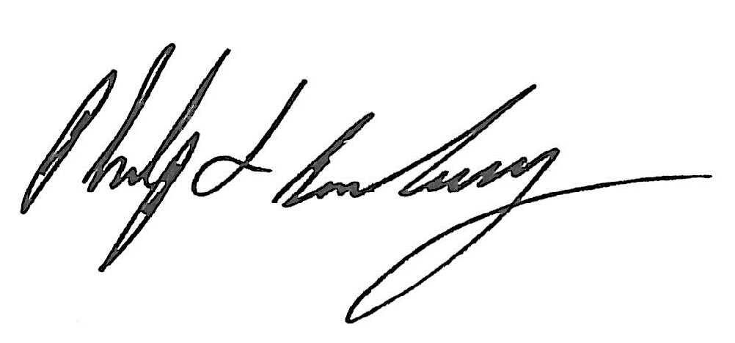

Philip S Brackney
Chairman
Board of Trustees
Metropolitan Detroit Youth Chorus

